***Test data***

Test data – denormalized table, used for load into stage.

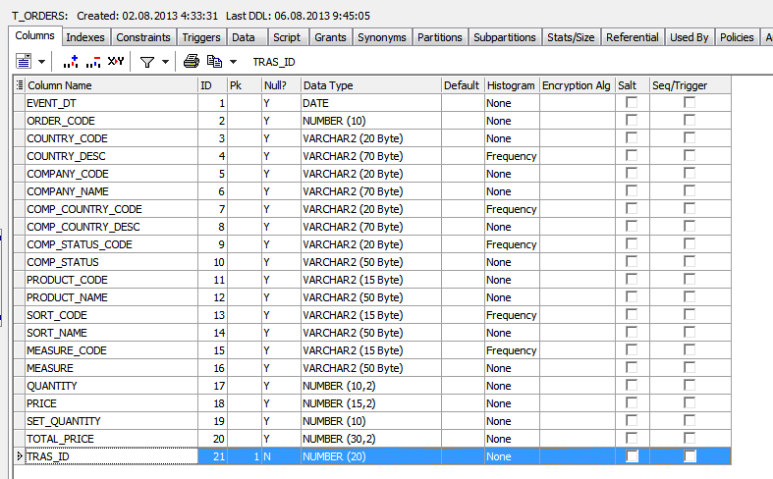

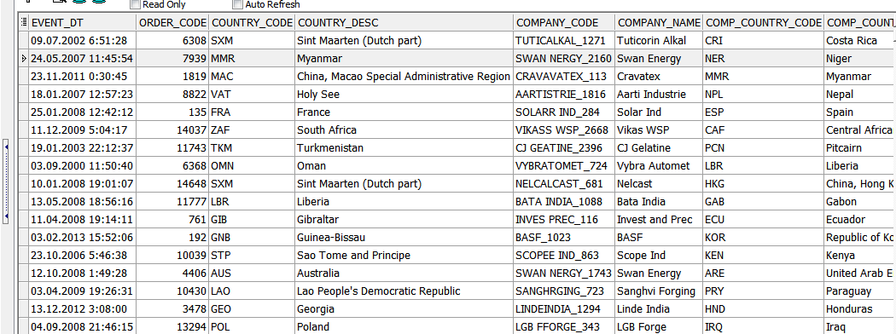

***Create Materialized Views - ON DEMAND***

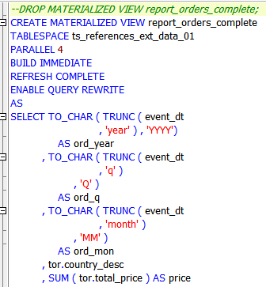

Refresh by command:

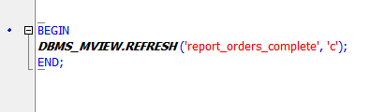

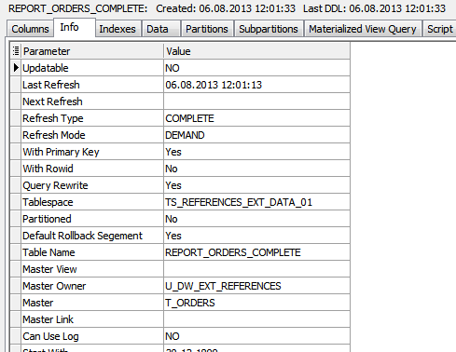

***Check rewrite***

|  |
| --- |
| alter session set query_rewrite_enabled = false;  alter session set query_rewrite_integrity = enforced; |

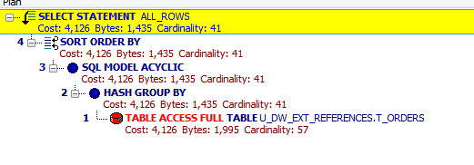

|  |
| --- |
| alter session set query_rewrite_enabled = true;  alter session set query_rewrite_integrity = enforced; |

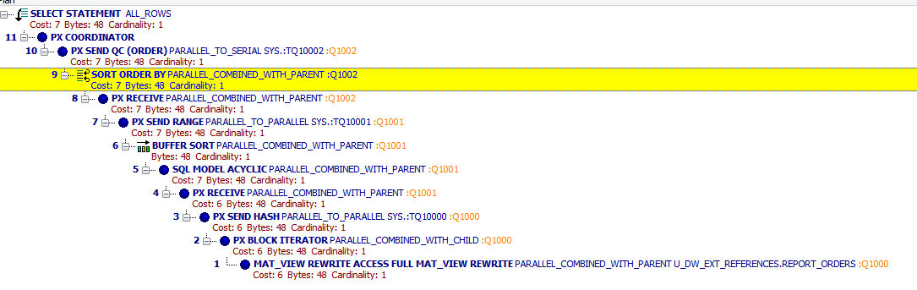

***Create Materialized Views - ON COMMIT***

Create Log

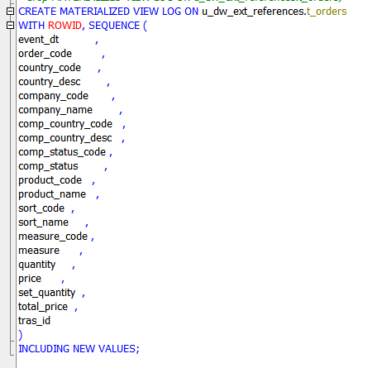

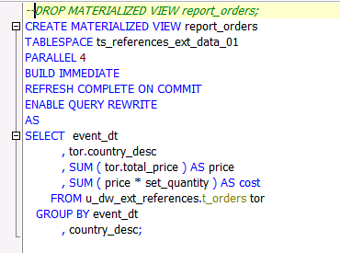

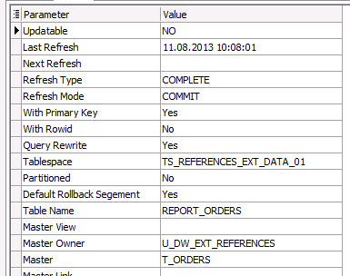

*Check rewrite*

|  |
| --- |
| alter session set query_rewrite_enabled = false;  alter session set query_rewrite_integrity = enforced; |



|  |
| --- |
| alter session set query_rewrite_enabled = true;  alter session set query_rewrite_integrity = enforced; |

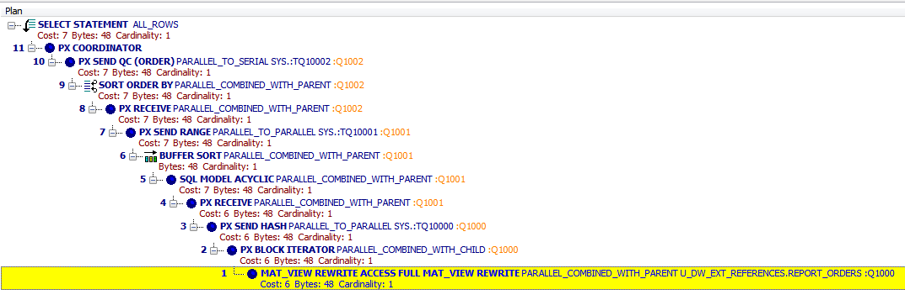

P.S.

Fast Refresh ON commit.   
Simple view build on u_stg.t_orders.

|  |
| --- |
| *--DROP MATERIALIZED VIEW LOG ON u_stg.t_orders;*  CREATE MATERIALIZED VIEW LOG ON u_stg.t_orders  WITH ROWID, SEQUENCE (event_dt, order_id )  INCLUDING NEW VALUES;  *--DROP MATERIALIZED VIEW last_orders;*  CREATE MATERIALIZED VIEW last_orders  TABLESPACE ts_stg_data_01  PARALLEL 4  BUILD IMMEDIATE  REFRESH COMPLETE ON COMMIT  ENABLE QUERY REWRITE  AS  SELECT event_dt, COUNT(DISTINCT order_id) AS cnt  FROM u_stg.t_orders  WHERE event_dt >= TO_DATE ('01/06/2013','dd/mm/yyyy')  GROUP BY event_dt; |

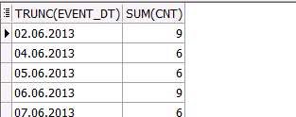

|  |
| --- |
| UPDATE t_orders  SET event_dt =  TO_DATE ( '02/06/2013'  , 'dd/mm/yyyy' )  WHERE TRUNC ( event_dt ) = TO_DATE ( '07/06/2013'  , 'dd/mm/yyyy' );  COMMIT;  SELECT TRUNC ( event_dt )  , SUM ( cnt )  FROM last_orders  GROUP BY TRUNC ( event_dt )  ORDER BY 1; |

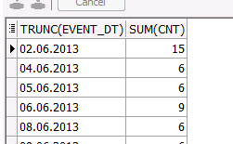

***Create Materialized Views - Refreshing at definitive Time moment***

This materialize view uses the view log, created in previous paragraph.

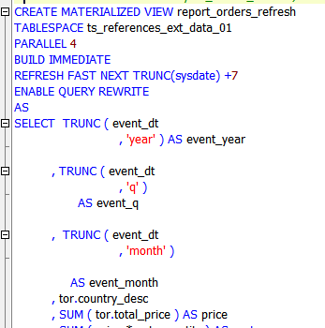

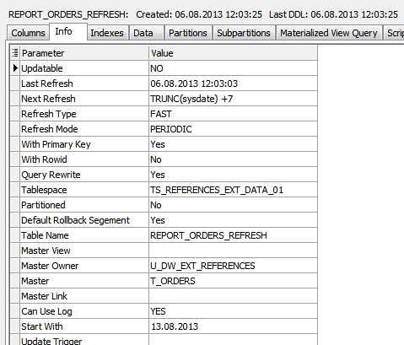

*Check rewrite*

|  |
| --- |
| alter session set query_rewrite_enabled = false;  alter session set query_rewrite_integrity = enforced; |



|  |
| --- |
| alter session set query_rewrite_enabled = true;  alter session set query_rewrite_integrity = enforced; |

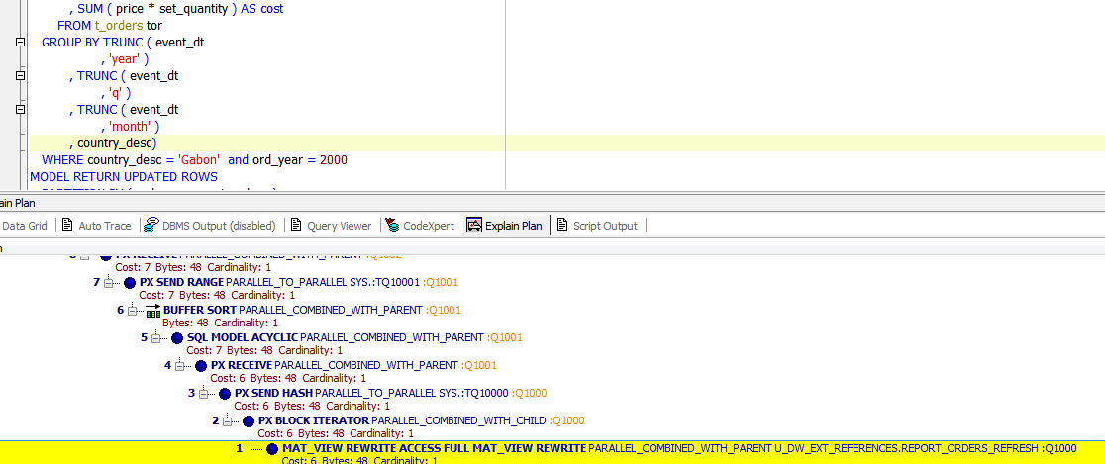

|  |
| --- |
| alter session set query_rewrite_enabled = false;  alter session set query_rewrite_integrity = enforced; |